Ecoventures
Zero Waste Startup Game

By

FEU Tech Innovation Center

Yvan Angelo G. Alcarioto - Programmer
Alec Miguel P. Fortes - Programmer
Vincent Thomas Jed J. Gabinete - Programmer
Luis Javier G. Montinola - 3D Artist
Solomon Enrico C. Monteverde VII - 3D Artist
Samuel Ghenvic Faith T. Tolentino - UI/UX Designer
Jose Lorenzo G. Tuazon - 3D Artist

Term 3TSY2526

Version 2

July 16, 2026

Overview of the Game
Ecoventures is a single-player arcade simulation–trivia game designed for Android mobile devices, developed using Unity and featuring an original 3D art style. The game is set within the campus environments of FEU Institute of Technology, including key areas such as the institute building and public spaces. It follows the journey of a student startup founder working to build a successful and sustainable business.
The game centers on a core gameplay loop where players procure materials through interactive arcade-style games. These materials are used in crafting products, requiring players to make careful decisions to ensure efficiency and sustainability. Once products are completed, they are sold to consumers to earn income and progress through the game.
A key feature of Ecoventure is its integration of the Zero Waste Infinite Solutions (ZWIS) initiative, which promotes responsible resource management and waste reduction. Players must ensure that both materials and products follow sustainable practices to maintain efficiency and meet objectives. This system reinforces the game’s educational aspect while adding depth to the overall gameplay.
The game is divided into three stages with increasing levels of difficulty and demand. In the first stage, the player manages all aspects of material collection, production and selling independently. As the game progresses, higher demand and limited resources require better planning and faster decision-making to succeed.
By combining arcade mechanics with simulation elements, Ecoventures offers an engaging and focused gameplay experience. It challenges the players to efficiently manage a startup while making environmentally responsible choices. The game delivers both entertainment and awareness through its sustainability-driven design.

Scope and Limitations

Scope
- Ecoventures is a single-player arcade simulation game for Android mobile devices, featuring an original 3D art style and campus-based settings at FEU Institute of Technology.
- The game emphasizes sustainability and the Zero Waste Infinite Solutions (ZWIS) initiative, requiring players to make environmentally responsible decisions in material selection, production, and sales.
- Players progress through three stages of increasing difficulty, facing higher demand and limited resources to simulate realistic startup challenges.

Limitations
- The game is limited to a single-player experience. There is no multiplayer or online component.
- The mobile version is designed specifically for Android devices, which may limit compatibility with other platforms.

Gameloop and Flowchart

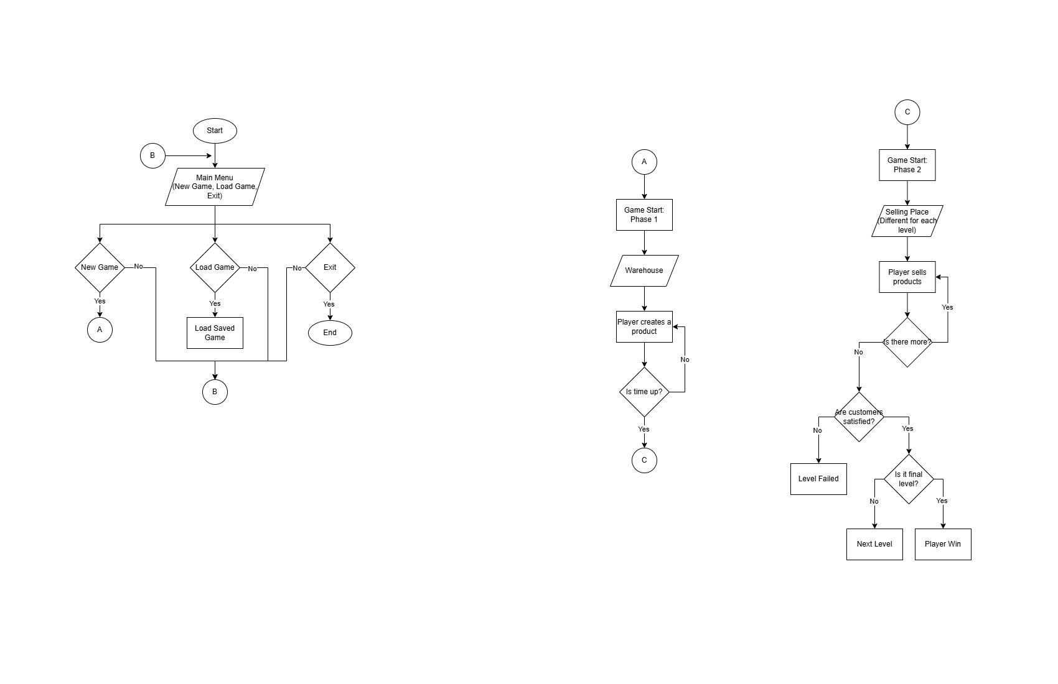

Image 1. Main Menu Flowchart

The image above shows how the main menu of the game flows. There are three choices for the player before starting the game: New Game to start a fresh game, Load Game to load a saved file, and Exit to exit the game.

Image 2. GameloopPhase1Simplified Image 3. GameloopPhase2Simplified

Image 2 illustrates the gameloop for the first phase of the game: the production phase. In this phase, the player creates numerous products as much as they can until the timer runs out. However, creating the products takes time and the player must plan out his actions and plan efficiently to ensure that he has enough products for the next phase. The next phase is the selling phase, illustrated on Image 3. The player sells his created products in this phase to customers and makes sure that the customers’ satisfactions are high and their patience does not run dry. The player has a set number of target sales for every level, and the higher the level, the harder the target to reach is.

Development Timeline

Week | Date | Phase | Tasks
1 | Apr 13 - 17 | Initial Meetings and Project Recollections | All members  - Re-introduction of members  - Reviewing of project specifications  - Reviewing and redefining project scope  - Identification of incomplete project requirements
2 | Apr 20 - 24 | Orientation and Redefinition of tasks | All members  - Redefining member roles  - Identification of new tasks per member roles  - Division of tasks
3-7 | Apr 27 - May 29 | Development Phase: Alpha Build and Missing Game Mechanics Completion | Programmers  - Finish game logic:  - Trivia logic  - Other UI logics  - Level 2-3 of the game  3D Artists  - Refine 3D assets  UI/UX  - Refining UI/UX Assets  - Creation of Comic-based cutscenes
8-10 | Jun 01 - Jun 19 | Development Phase: Alpha Build Test and Refinement based on feedback | All Members  - Conduct initial alpha test with members and other related parties.  - Gather data and suggestions  - Identify bugs to fix  - Identify aspects to refine  - Refine game based on feedback
11-12 | Jun 22 - Jul 03 | Development Phase: Final Adjustments / Buffer week | All Members  - Conduct Final Adjustments  - Conduct Final Testings  - Prepare Beta Testing Questionnaire  - Buffer week
13-14 | Jul 6 - 16 | Beta Testing | All Members  - Gather enough respondents for testing  - Gather feedback from respondents  - Analyze gathered data  - Refine game based on gathered Data
1-14 | April 13 - Jul 16 | Refinement Based on feedback | All Members  - Refine game based on beta testing data  - Refine game based on feedback from peers and advisor

Table 1. Game Development Timeline 1
Table 1 is the Game Development Timeline for the development of the game entitled “Ecoventures”. From April 13 to July 16, the team worked on the continued development of the game through several structured phases. The project began with initial meetings where members were reintroduced, project specifications and scope were reviewed, and incomplete requirements were identified. This was followed by an orientation phase in which member roles were redefined, new responsibilities were assigned, and tasks were divided among the team. During the main development phase, programmers completed core game mechanics such as trivia systems, UI logic, and Levels 2 and 3, while 3D artists refined game assets and the UI/UX team improved interface designs and created comic-based cutscenes. After completing the alpha build, the team conducted internal testing to identify bugs, gather feedback, and implement necessary refinements. The succeeding weeks were dedicated to final adjustments, additional testing, and preparation of the beta testing questionnaire. Beta testing was then carried out by collecting respondents, gathering and analyzing feedback, and using the results to further improve the game. Throughout the internship, the team continuously refined the project based on input from beta testers, peers, and their advisor to ensure a more polished and stable beta version.
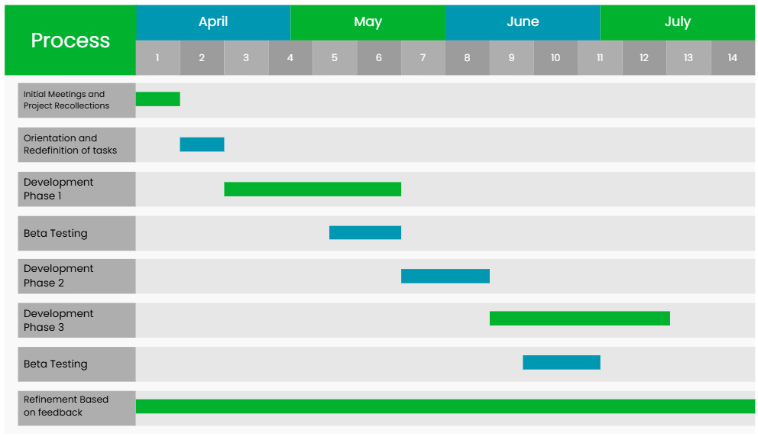
Image 1. Ecoventures Timeline Gantt Chart
Image 1 better illustrates the project development phase through a gantt chart illustration.

Developer’s Manual

Short Overview
Ecoventures is a single-player arcade simulation game for Android where players manage a student startup, procuring materials and creating products while following eco-friendly, zero-waste principles. The game integrates core systems such as inventory management, customer behavior, currency, and product creation, all designed to provide a smooth and strategic gameplay experience. This manual provides guidance for developers to understand the project’s architecture, key scripts, scene setup, and mechanics, making it easier to maintain, update, or expand the game.

Import Package
TextMeshPro - For UI text elements and dynamic text rendering.
AI Navigation - For AI pathfinding of customers and NPCs.
Input System - Manages player input and interactions.
uGUI - Used for all user interface elements such as buttons, panels, and HUD.
Universal Render Pipeline (URP) – Provides optimized rendering for performance and visuals.
Universal Render Pipeline Config – Contains configuration settings for URP.
Shader Graph – Used for creating custom shaders.
Scriptable Render Pipeline Core – Core framework for rendering pipelines.
Cinemachine – Enables smooth and dynamic camera control.
Splines – Supports path-based movement and positioning.
Burst – Improves performance by compiling high-performance code.
Mathematics – Provides advanced math functions for game calculations.
Collections – Offers optimized data structures for performance.
Test Framework – Supports unit testing within the project.
Performance Testing API – Used for performance measurement and optimization.
Custom NUnit – Testing framework dependency.
Visual Studio Editor – Integration with Visual Studio for scripting.
JetBrains Rider Editor – Integration with Rider IDE.
Visual Scripting – Allows node-based scripting (if used).
Settings Manager – Manages project and user settings.
Searcher – Supports search functionality in editor tools.
Mono Cecil – Used internally for code analysis and compilation.

Scenes
MainMenu - The Main Menu scene provides the starting interface where players can navigate options like starting, continuing, or exiting the game.
Workshop - The Workshop scene is where players create products using scrap materials before selling them.
Map - The map is where the player will choose for their level.
Level 1 - The first level of the game, where the setting is in FEU Tech Innovation Center lounge.
Level 2 - The second level of the game, where the setting is in FEU Tech.
Level 3 - The third level of the game, where the setting is in the open area of the FEU Tech building.

Script Functionality
Assets/Scripts/Audio
AudioManager.cs – Singleton that centralizes SFX and music playback, offering one-shot SFX, looped SFX (with start/stop control), and music playback through dedicated AudioSource components.

Assets/Scripts/Counters
Counter_Audio.cs – A simple data container holding AudioClip references (correct/wrong entry, interact, cooking, burning, overcooked) that other counter scripts pull from for their sound effects.
Counter_Base.cs – Abstract-ish base class implementing IItemParent that all counters inherit from; handles shared item-holding logic (SetItem, GiveItem, HasItem, ClearItem) and defines virtual Interact/InteractAlternate methods for subclasses to override.
Counter_Bin.cs – A trash counter: if the player is holding an item, it destroys that item, fires an OnPlayerThrewObject event, and plays an interact SFX.
Counter_Container.cs – A purchasable item dispenser: lets the player buy/take a specific Item_Data (deducting money or pulling from recycled stock first), or place/retrieve items normally, updating the container UI and playing SFX on interaction.
Counter_Disassemble.cs – A recycling counter: if the player submits an item matching a disassembly recipe, it destroys the item and adds the recipe's output materials to inventory, firing OnItemDisassemble and playing SFX.
Counter_Empty.cs – A general-purpose workbench: lets players place/pick up items, and if both the counter's and player's items match a combination recipe, consumes both and spawns the recipe's output item.
Counter_Process.cs – A manual-progress station (e.g., chopping): accepts an item with a matching recipe, then requires repeated InteractAlternate calls to increment a timer until the process completes and spawns the output item, firing progress-changed events and SFX along the way.
Counter_Progress.cs – An automatic time-based cooking station: cycles through Idle → Cooking → Burning → Overcooked states in Update(), playing looped cooking/burning SFX, swapping items at each stage transition, and exposing progress/burn state via events and helper methods.
Counter_QTE.cs – Entirely commented-out (dead/WIP code); appears to be a planned quick-time-event variant of Counter_Process that isn't currently active.
Counter_StorageBin.cs – A finished-goods pickup counter: lets the player retrieve the next available item from a shared inventory's _finalProducts list (or drop an item onto it), updating the storage UI and playing SFX.
Counter_Submit.cs – An order/turn-in counter: checks if the player's item matches one of the accepted final products, and if so destroys it, adds a random quantity to inventory, reports the sale to the achievement manager, and fires OnItemSubmit; plays correct/wrong SFX depending on the outcome.

Assets/Scripts/Data
Achievement_Data.cs – Simple ScriptableObject holding a single achievement's title and icon sprite, with a getter for the title.
Achievement_Progress.cs – Tracks player achievement state: five named achievement flags (e.g. CURIOUS_JED, QUIZ_RUSH) plus private counters for items unlocked/sold/crafted/thrown and hints viewed, with add/check methods for each counter and a Reset() to clear all flags.
Dialogue_Data.cs – Defines a dialogue sequence asset: a title, a DialogueType (standard/start/middle/end), an array of Dialogue lines (actor ID + message text), and an array of Actor definitions (name + avatar sprite).
Dialogue_Progress.cs – Tracks which one-time dialogues have already been triggered (workshop intro/tutorial flags, map flags, stage 1 intro) as booleans, with a Reset() to clear them all for a new playthrough.
GameInventory_Data.cs – Central shared inventory/economy ScriptableObject: holds lists of finished products and recycled materials plus player money, with add/remove methods for each and static events (OnInventoryDataChanged, OnMoneyValueChanged) that fire on any change.
GameProduct_Randomizer_Data.cs – Holds a list of currently "allowed" items (likely for randomized product demand per stage), with methods to clear, add, and check membership.
Hints_Data.cs – Holds a stage name and an array of hint sprites, used as the data source for the per-stage hint pool (referenced in your shuffle-pool hint system).
Item_Data.cs – Core item definition: prefabs (world group + pickup), sprite, name, unlock state, and sell price, with getters for name and sprite; this is the base data type referenced throughout the counter and recipe scripts.
ItemCombinationRecipe_Data.cs – Defines a two-input combination recipe (item1 + item2 → outputItem) with a progress duration, used by Counter_Empty.
ItemDisassemblyRecipe_Data.cs – Defines a disassembly recipe: one input item mapping to an array of output items, used by Counter_Disassemble.
ProccesRecipe_Data.cs (ProcessRecipe_Data) – Defines a single-input/single-output manual process recipe with a progress duration, used by Counter_Process.
ProgressRecipe_Data.cs – Defines a three-stage cooking recipe (unfinished → finished → overcooked item) with a timer duration, used by Counter_Progress.
Questions_Data.cs – Holds a quiz question: the question body, correct answer, three wrong answers, and an associated NPC sprite, used by your booth quiz panel system.
RandomNPCDialogue_Data.cs – Holds a stage ID and an array of random flavor dialogue lines for roaming/idle NPC chatter on that stage.
Recipe_Data.cs – Minimal asset holding just an array of recipe sprites, used for guidebook recipe-detail display.

Assets/Scripts/Interface
IItemParent.cs – Interface defining the contract for any object that can hold an Item_Base (get follow transform, set/give/clear item, check if it has one); implemented by Counter_Base and Player_Base.
ToggleImages.cs – UI helper that finds/uses a set of Toggle components and swaps between "on" and "off" child image states based on each toggle's current value.

Assets/Scripts/Items
Item_Base.cs – The MonoBehaviour attached to physical item instances in the world; handles re-parenting itself between IItemParent holders (counters/players), and provides a static SpawnItem factory method to instantiate and immediately parent a new item.
ItemGroup_Base.cs – Attached to grouped-item prefabs; stores the Item_Data the group represents and an array of child GameObjects representing different remaining-stock visual states (used by ProductPrefabChanger).

Assets/Scripts/Managers
Achievement_Manager.cs – Singleton that listens for gameplay progress reports (items unlocked, sales, hints viewed, products registered/thrown) via a no-op-once-earned API, checks each against a threshold constant, and triggers/displays the matching Achievement_Data popup when a goal is met.
Game_Manager.cs – Core singleton managing global game state: pause/resume via Time.timeScale, returning to main menu, quitting, a debug-mode flag, and an achievement-broadcast event.
Interaction_Manager.cs – Singleton that listens to player input events and forwards Interact/InteractAlternate calls (with a one-frame delay via coroutine) to whichever IInteractable is currently focused, and manages focus enter/exit when the focused interactable changes.
Map_Manager.cs – Handles interaction with a map stage node: transitions to that stage's scene via Scene_Manager and sets the allowed product pool via AllowedProducts_Manager.
MapSpawner_Manager.cs – Empty stub MonoBehaviour with unused Start/Update; no functionality implemented yet.
SaveAndLoad_Manager.cs – Handles JSON-based save/load to disk per slot: serializes player money, sales, unlocked/final products, and dialogue-progress flags into a SaveData object, writes/reads it from Application.persistentDataPath, and applies loaded data back into the relevant ScriptableObjects and managers on load.
SaveSlotUI.cs – UI component that reads save files for up to 3 slots directly from disk and updates each slot's date/completion-percentage text display (independent of SaveAndLoad_Manager's in-memory data).
Scene_Manager.cs – Singleton controlling scene transitions via a fade animator: triggers the fade, then loads the target scene index once the fade-out animation event fires, and exposes a fade-complete event for other systems to hook into.
Unlock_Manager.cs – Singleton managing item unlock state: RequestUnlock only finalizes an unlock once ObjectivesTracker's objectives are met, otherwise queuing the item as "pending" until objectives complete (auto-subscribing to that completion event); also exposes direct Unlock/Lock/SetUnlocked and reports unlocks to Achievement_Manager.
WorkshopUI_Manager.cs – Singleton managing workshop-scene UI: toggling main UI panels visible/hidden, firing guidebook open/close/click events, and showing/hiding tutorial "pointer" UI elements tied to specific dialogue names.

Assets/Scripts/Managers/Dialogues
Dialogue_Manager.cs – Singleton that looks up a Dialogue_Data by title, hands it to Dialogue_UI to display, pauses the game, and fires an OnStartDialogue event with the dialogue's title.
Dialogue_UI.cs – Singleton controlling the dialogue box UI: displays messages/actor name/avatar line-by-line, drives animator triggers based on DialogueType (standard/start/middle/end), advances via NextLine(), and fires OnDialogueEnd for chained or tutorial-linked dialogues.
SceneDialogues_Workshop.cs – Singleton driving the long chained tutorial dialogue sequence in the workshop scene: fires the intro dialogue on scene fade-in, then chains through a dozen+ guidebook/movement/grab tutorial steps (each triggered by the previous one's OnDialogueEnd or by external UI/game events), tracking completion via Dialogue_Progress flags and supporting a debug reset.

Assets/Scripts/Managers/Guidebook
Guide_Buttons.cs – Populates a row of recipe-unlock buttons in the guidebook: sets each button's icon from its matching Item_Data, and makes the button interactable (and full-color vs. black tint) only if that item is unlocked.
Guide_Manager.cs – Drives the multi-tab guidebook UI: switches between main category pages, opens a recipe-detail sub-page (via Guide_RecipePage) for a given index or Recipe_Data, and handles the back button to restore the previous main page and toggle state.
Guide_RecipePage.cs – Displays a two-page-spread view of a recipe's step sprites, letting the player page forward/backward two sprites at a time (left/right page images) and hiding/showing next/previous buttons based on whether more pages exist.

Assets/Scripts/Managers/Selling/Playerside
CameraFollow.cs – Simple LateUpdate camera rig that follows a target transform at a fixed height/offset with a locked downward tilt.
IInteractable.cs – Interface for anything the player can interact with via Interaction_Manager: Interact, InteractAlternate, and focus enter/exit callbacks.
InventoryManager.cs – Singleton wrapper around GameInventory_Data's final-products list; adds/removes single item instances and fires an OnInventoryChanged event (item + new remaining count) so UI and prefab visuals can react without polling.
ObjectivesTracker.cs – Singleton tracking sales-based objectives (regular sales goal + special-order goal): listens to SalesTracker's sale events, updates task-progress UI text, and fires OnObjectivesCompleted once both goals are met; also exposes IsRegularGoalMet() for RoamingNPC's special-customer queue-bias logic.
ProductPrefabChanger.cs – Sits on a spawned product-group prefab alongside ItemGroup_Base; listens for inventory changes to its specific item and toggles visual "stock remaining" stages (e.g. 100/75/50/25%) proportional to how much of the initial stock is left.
ProductSpawner.cs – At scene start, spawns one visual product-group prefab per allowed/unlocked item (with stock remaining) at designated spawn points on the selling stage.
RemainingProductsUI.cs – Updates a row of text fields showing how many of each allowed product remain in inventory, refreshing on InventoryManager.OnInventoryChanged.
RoamingNPC.cs – NavMesh-driven NPC wandering behavior: picks random roam/vendor points (reserving them to avoid collisions between NPCs), waits and faces vendor tables on arrival, joins the CustomerQueue when reaching a vendor point (handing off control to queue logic), includes anti-stuck repathing, and for special customers weights point-selection toward vendor stalls once the regular sales goal is met.
SalesTracker.cs – Singleton handling money/sale registration: RegisterSale for normal one-item sales (removes stock, adds money, increments totalSales), plus special-order support (ReserveStockForSpecialItem, RefundReservedItems, CompleteSpecialSale) that only awards money once a full multi-item special order completes; also tracks the currently selected product for the selling-UI tap flow and reports sales to Achievement_Manager.
SellingMode.cs – Trigger-based IInteractable that, when the player enters/exits its collider, registers/clears itself as the focused interactable, and on interact switches the UI into selling mode via UI_Manager.
SellingProductButton.cs – UI button representing one sellable product; shows its icon and, on click, sets it as the currently selected product on SalesTracker for the next sale attempt.
SellingProductsUIManager.cs – Assigns the game's allowed items to a fixed set of SellingProductButtons at start, activating/deactivating buttons based on how many allowed items exist.
UI_Manager.cs – Central singleton for toggling major UI/camera states (explore mode, selling mode, hint panels, quiz booth panels with right/wrong feedback, pause menu), consolidating what's active in each mode.

Assets/Scripts/Managers/Selling/RegularNPCs
CustomerOrder.cs – Base class for a customer's order lifecycle: generates a requested item, moves the NPC to a queue point and faces the vendor, shows the order-bubble UI once facing is confirmed, tracks a wait timer that triggers an automatic walk-away if unfulfilled, and handles order completion (TryCompleteOrder, registering the sale via SalesTracker) plus shared cleanup (LeaveQueueAndResume) that removes the customer from the queue and resumes NPC roaming; designed with virtual methods (GenerateOrder, TryCompleteOrder, LeaveQueueWithoutOrder, ResetOrderState) for SpecialCustomerOrder to override.
CustomerQueue.cs – Singleton managing the physical/UI queue of up to N customers at a vendor table: assigns each new customer a queue point and corresponding UI bubble slot, defers showing the order bubble until the customer is actually facing the vendor (via OnFacingVendor), and handles removing a customer (hiding their bubble and the vacated slot's UI) while collapsing the queue.
OrderBubbleButton.cs – UI button attached to each order bubble; on click, tells SalesTracker to try completing that specific customer's order using whatever product the player currently has selected.
OrderGenerator.cs – Singleton that returns a random Item_Data from the current stage's allowed-items pool, used by CustomerOrder/SpecialCustomerOrder to generate what a customer wants.

Assets/Scripts/Managers/Selling/SpecialNPCs
SpecialCustomerOrder.cs – Subclass of CustomerOrder for multi-item (default 3) sequential special orders: generates a randomized item list, reveals one requested item at a time via the same order-bubble UI, reserves stock per item as each is fulfilled without paying out, and only awards money/counts the sale once all items are completed; refunds already-handed-over items if the customer leaves early via LeaveQueueWithoutOrder.

Assets/Scripts/Player/Map
AllowedProducts_Manager.cs – Randomly picks one item from each of three predefined item pools (ensuring no duplicates), displays their sprites on the map UI (dimmed if locked), and pushes the final selected trio into GameProduct_Randomizer_Data when entering a stage.
Map_Player.cs – Map-scene player controller: handles grid-free movement/collision (same capsule-cast sliding logic as Player_Base) and raycasts forward to detect and select a Map_Manager stage node, firing its Interact() on player input.

Assets/Scripts/Player/Workshop
Player_Audio.cs – Plays looped footstep SFX while the player is walking (stage scene) and plays pickup/drop one-shot SFX based on whether the player's item state changed after an interact action.
Player_Base.cs – Core singleton player controller for the stage scene: handles movement/collision, raycasts forward to detect and select a Counter_Base, forwards Interact/InteractAlternate to the selected counter, implements IItemParent to hold items, and fires events for UI/audio/visuals to react to (grabbed object, pickup, drop, counter selection, container-counter selection).

Player_CameraShaders.cs – Detects via raycast whether the player is occluded behind a wall from the camera's view and adjusts two "see-through" shader materials' size/position properties accordingly (x-ray/silhouette effect).
Player_Input.cs – Wraps the generated PlayerInputActions input asset, exposing Interact/InteractAlternate as C# events and normalized movement vector, with a scene-specific input inversion hack for certain scenes.
Player_UI.cs – Toggles visibility of pickup/drop button icons based on whether the player is currently holding an item.
Player_Visuals.cs – Drives the player's Animator "Move" and "Carry" bools based on Player_Base's walking/holding state.

Assets/Scripts/PopupScripts
BoothInteractable.cs – Quiz-booth trigger interactable: opens a quiz panel on interact, deactivates itself if its item is already unlocked, and on right/wrong answer shows result UI and either requests an unlock (via Unlock_Manager, which may queue it pending sales objectives) or locks the item; auto-closes on player exit and re-syncs via Unlock_Manager's unlock-state-changed event.
BoothQuizPanel.cs – Populates and manages the quiz UI for a given Questions_Data/Item_Data: builds and shuffles the four answer options, binds button clicks, displays question text/item sprite/NPC sprite, and reports the selected answer's correctness back to the owning BoothInteractable.
HintDisplayPanel.cs – Simple UI component that sets and enables a hint image sprite.
HintInteractable.cs – Trigger-based hint-station interactable: on first Awake, draws a sprite from a static Fisher-Yates-shuffled per-Hints_Data pool (rebuilding/reshuffling once exhausted) so hints don't repeat across interactables sharing the same data; opens the hint panel on interact and reports the view to Achievement_Manager.
NPCDialoguePopup.cs – Trigger-based idle-chatter popup: shows a random line from RandomNPCDialogue_Data when the player enters its collider, and hides/clears it on exit.
NPCDialogueUI.cs – Makes a world-space UI element (like the popup above) always face the camera by matching its forward direction each frame (billboarding).
SellingPhaseTutorialMenu.cs – Step-by-step onboarding tutorial overlay for the selling stage: walks through Recipe_Data tutorial sprites with next/previous navigation, shows a close button on the last step, and once closed marks Dialogue_Progress.STAGE1_INTRO so it won't show again and reveals the main selling UI.

Assets/Scripts/Visuals/Cutscenes
EndingCutscene.cs – Plays a video cutscene once ObjectivesTracker reports all objectives completed (also checking immediately on enable in case objectives finished before this script subscribed).
MainMenu_IntroCutscene.cs – Plays the main menu's intro video and triggers a fade animation when it finishes (or is skipped), then hides the cutscene canvas.

Assets/Scripts/Visuals/MainMenu
Office_Animation.cs – Simple animator trigger wrapper for an office scene, plus a method to fade/transition to the workshop scene.

Assets/Scripts/Visuals/Map
Map_PopupUI.cs – Detects via OverlapSphere whether the map player is within range and toggles a "Popup" animator bool on a target UI element accordingly (e.g. a stage info popup).

Assets/Scripts/Visuals/Workshop
Money_UI.cs – Displays the player's current money, refreshing whenever GameInventory_Data.OnMoneyValueChanged fires.
OnHandIndicator_UI.cs – Shows/hides an icon of whatever item the player is currently carrying, updating on pickup/drop events.
Timer_UI.cs – Countdown timer UI with a radial fill bar that shifts green→yellow→red as time runs low, updates a MM:SS text display, and triggers a scene transition to the map when time expires; exposes a switch to pause/resume the timer.

Assets/Scripts/Visuals/Workshop/Counters
BinCounter_Animation.cs – Plays an "Interact" animator trigger when the trash counter's OnPlayerThrewObject event fires.
ContainerCounter_Animation.cs – Plays an "Interact" animator trigger when the container counter's OnPlayerGrabbedObject event fires.
ContainerCounter_UI.cs – World-space billboarded UI panel showing a container counter's price (₱) or, if it's a recycled-material item, the current recycled stock count; shows/hides based on whether the player has this counter selected.
Counter_Selected.cs – Generic "selection highlight" component: shows/hides a set of visual GameObjects based on whether the player currently has this specific counter selected.
Counter_Sprite.cs – Billboarded panel showing a counter's assigned sprite icon, visible only when selected by the player and the counter has no item currently on it.
ProcessCounter_Animation.cs – Plays an "Interact" animator trigger each time the process counter's OnProcessCounterInteract event fires (each manual progress tick).
ProcessCounter_UI.cs – Billboarded progress bar for Counter_Process, shown while progress is between 0 and 1 and hidden at the start/end states.
ProgressCounter_Animation.cs – Toggles a "Smelting" animator bool based on Counter_Progress's cooking state (start/stop cooking animation).
ProgressCounter_UI.cs – Billboarded progress bar for Counter_Progress: shows fill progress in yellow/green while cooking and switches to red/pink while burning; hides when idle or when the item is removed.
RecyclingTable_UI.cs – Shows a popup animation and the output item's sprite whenever a disassembled material is added (via NotifyItemAdd, called from Counter_Disassemble — though currently commented out there).
StorageBin_UI.cs – Billboarded panel showing the next available finished-product sprite in the storage bin (or fading to transparent if empty), shown only when the player has this counter selected, refreshing on inventory changes.
SubmitCounter_Animation.cs – Plays an "Interact" animator trigger when the submit counter's OnItemSubmit event fires (a correct order turn-in).

Appendices

Design Assets

Game Characters  - Special NPC 1  - NPC Female  - Main Character  - NPC Male  - Special NPC 2 | 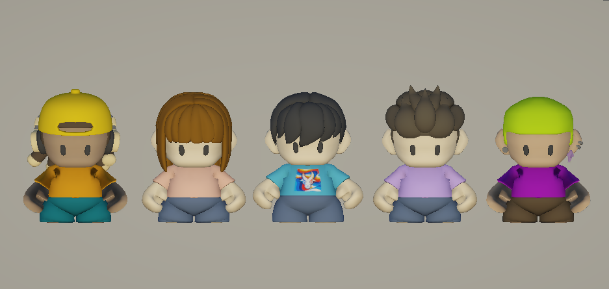
Game Stages  - Workshop  - Stage 1 - FTIC Lounge Area  - Stage 2 - FEU Tech Lobby Area  - Stage 3 - FEU Manila Freedom Park Area | 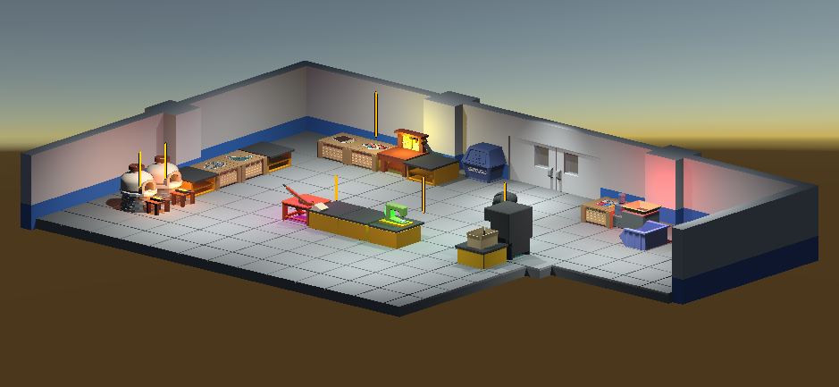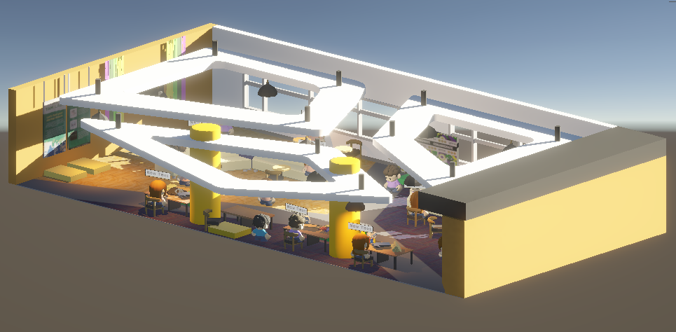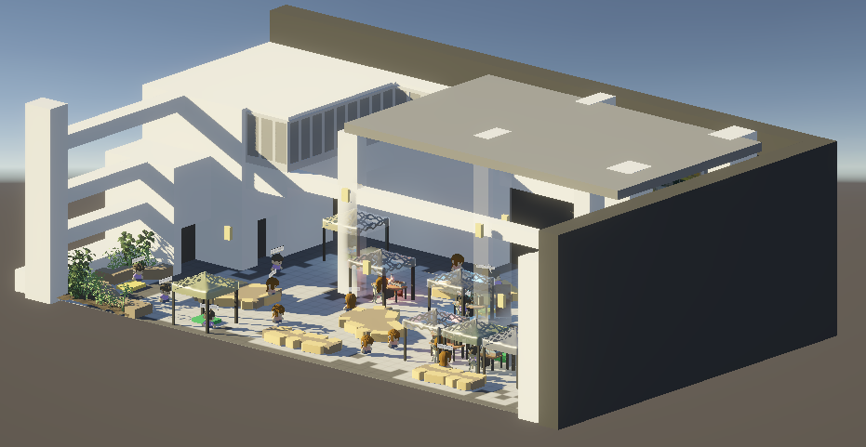  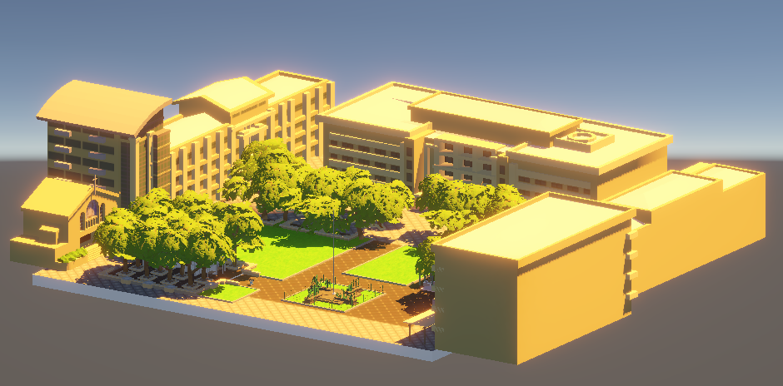
Stage Selection (Map) | 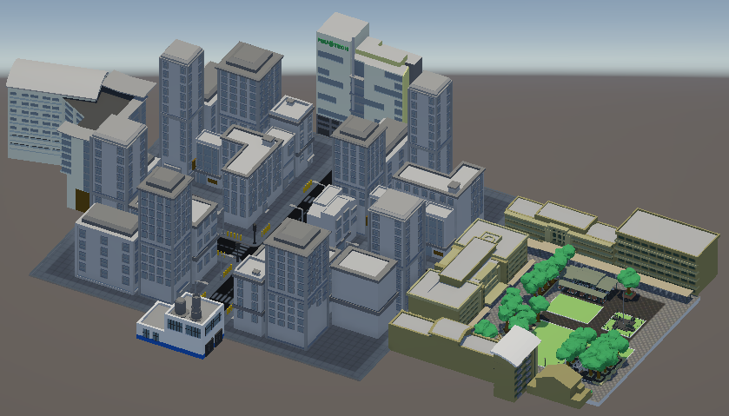
Workshop Tables  - Recycling Bin  - Empty Counter 1  - Empty Counter 2  - Material Container  - Product Container  - Sewing Machine  - Assembly Table  - Press  - Material Cutter  - Disassembler | 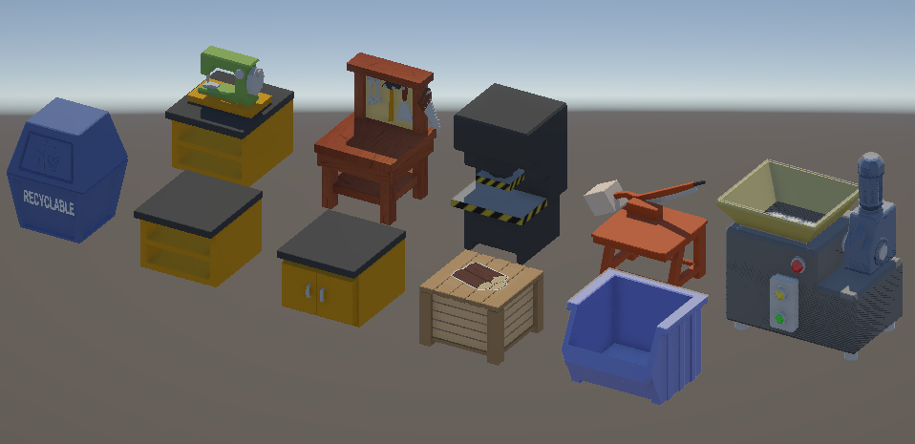
Products  - Keychain  - Lanyard  - Mug  - TShirt  - Totebag  - Button Pin  - Bracelet  - Cap  - Figurine | 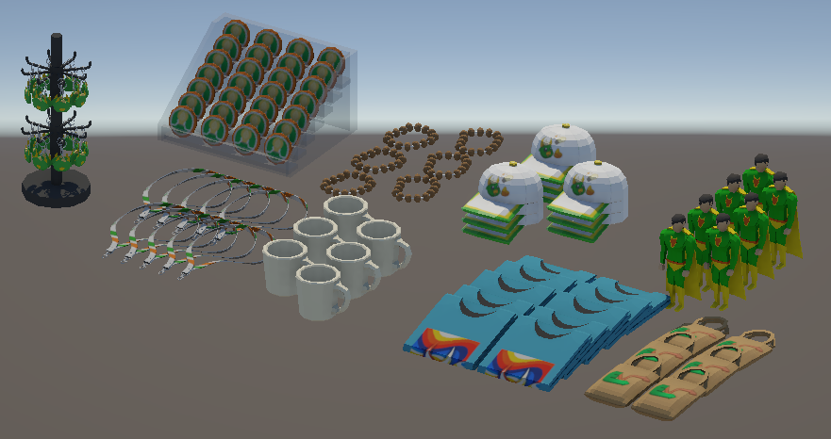

UI Assets

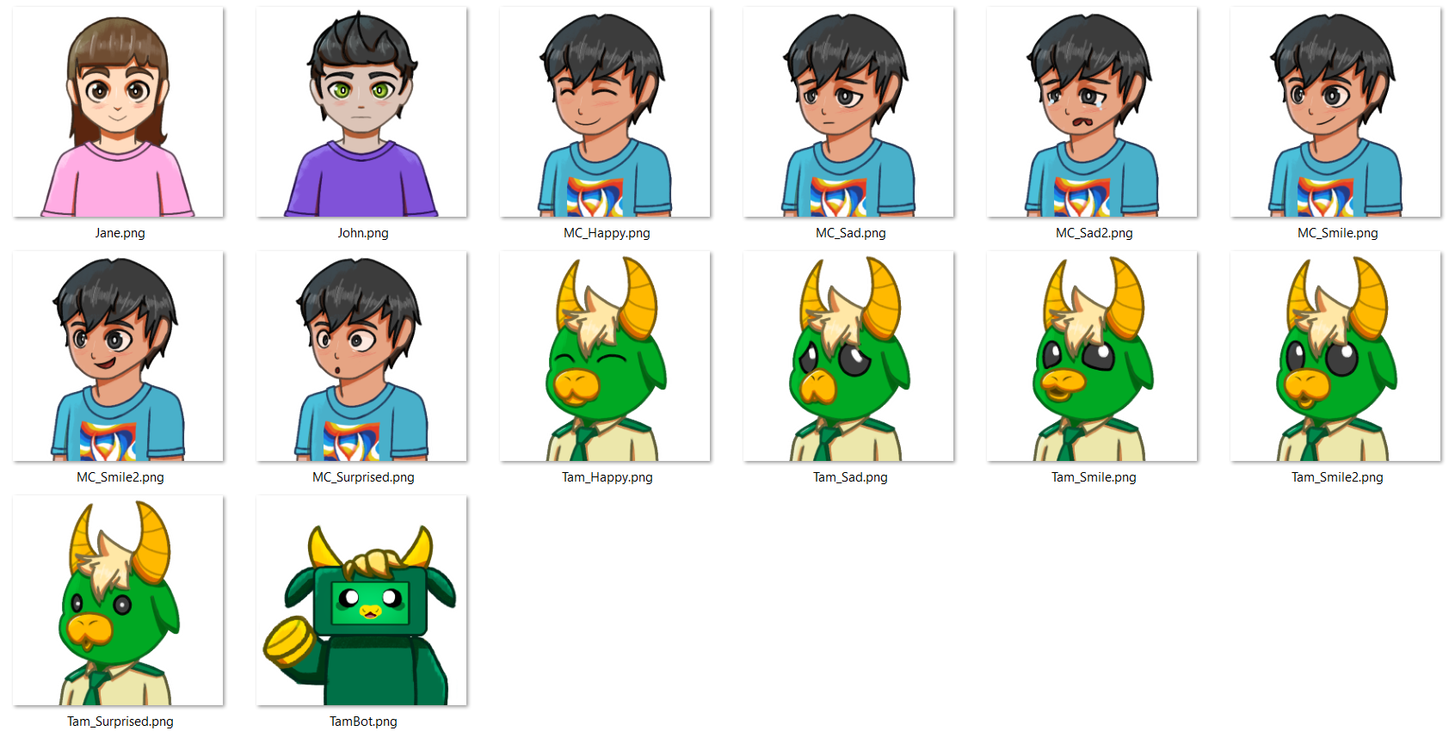 | 
Character UI (MC and Tammy, used for dialogues, the rest as quiz NPCs) | EcoVentures Title
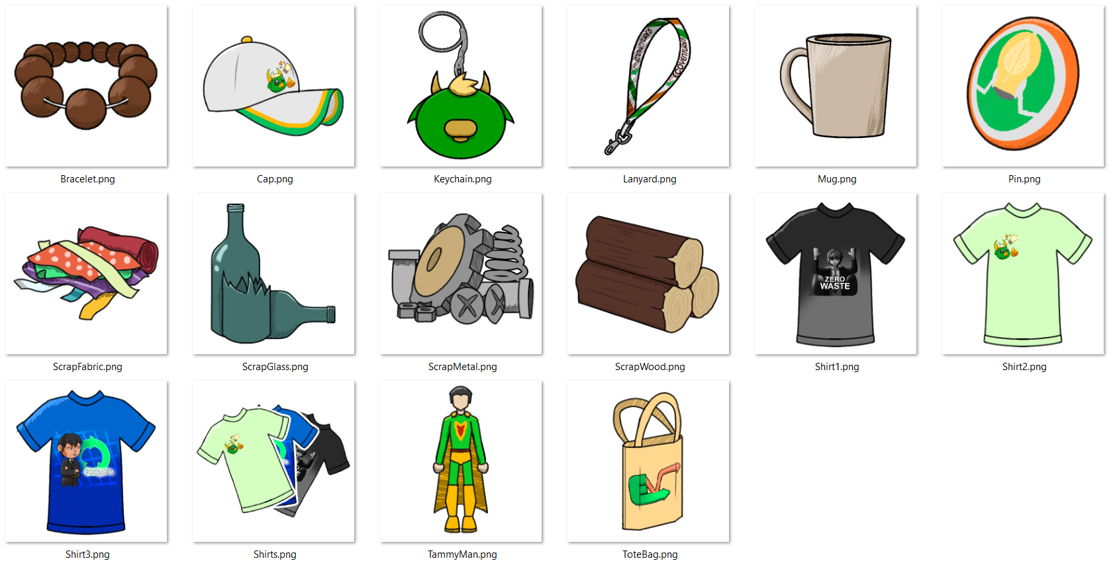 | 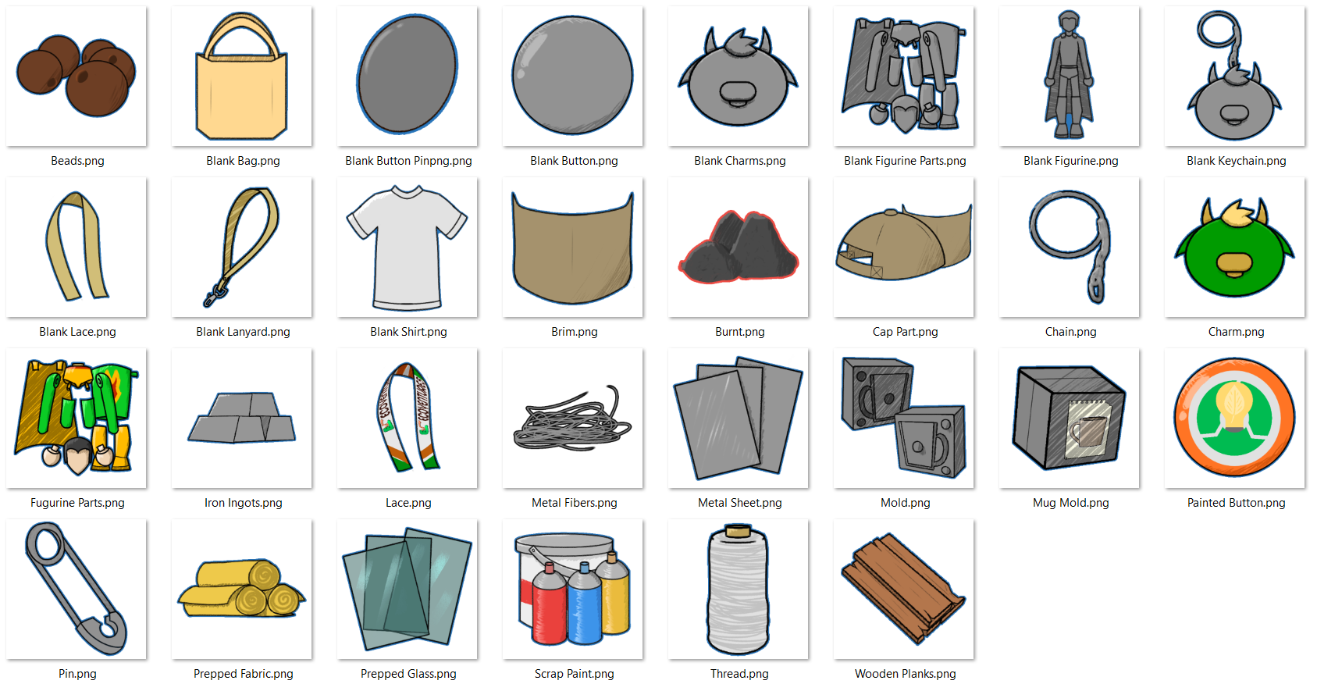
Raw materials and Final products icons (all icons for materials and products) | Intermediary Items (all icons in between crafting recipes)
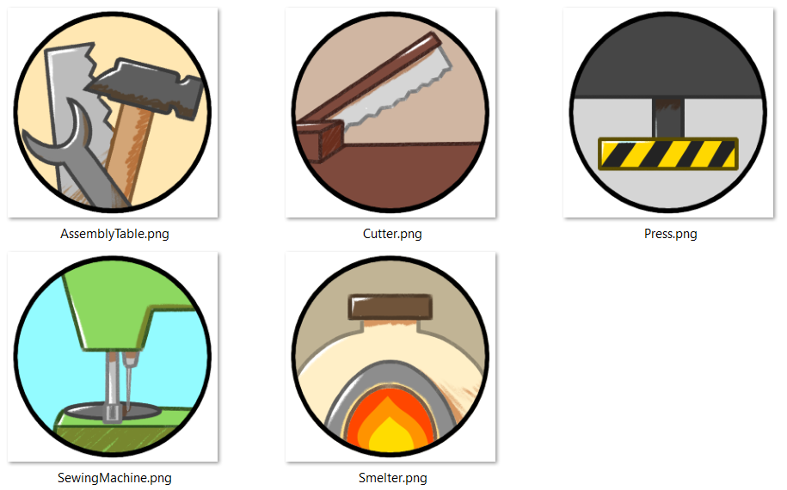 | 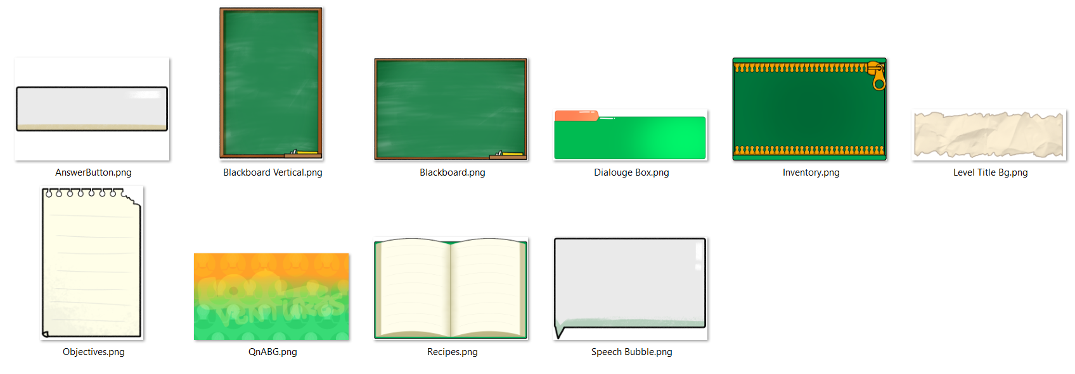
Facilities Icons (All icons for all interactable facilities) | Panels (Dialogue, inventory, objectives/guide, backgrounds, and pause/menu panels)
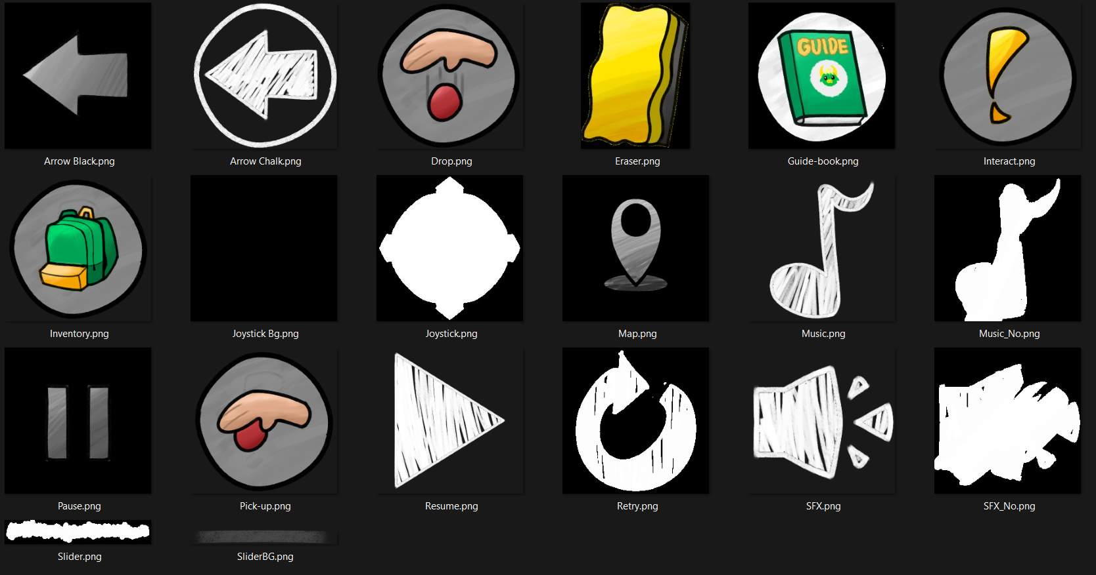 | 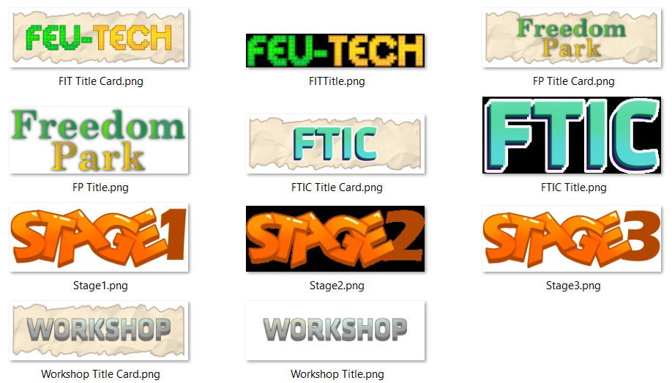
In-Game buttons (Control Buttons, Settings Buttons, Pause/Menu Buttons) | Map Icons (Stage title cards)
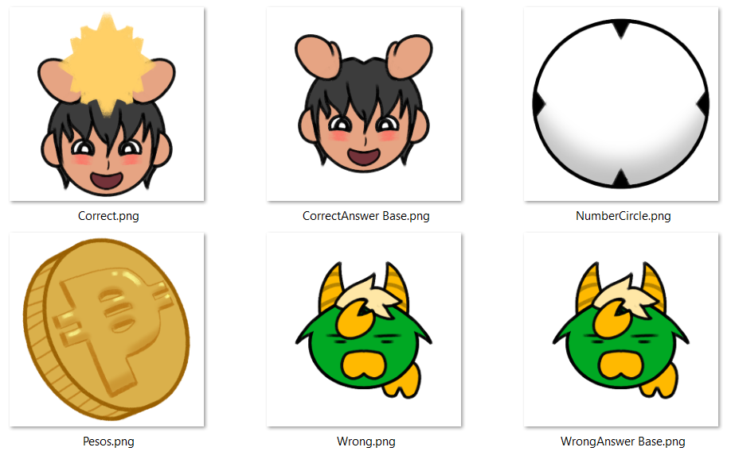 | 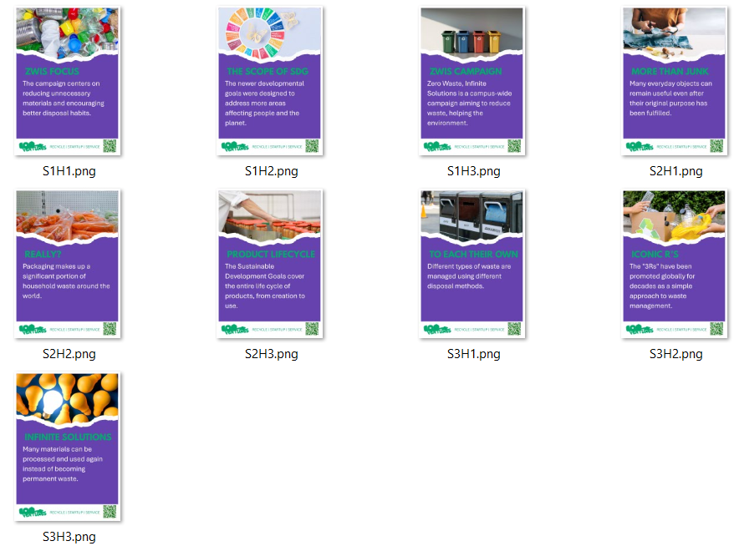
Selling Phase Icons (Correct and Wrong answer Indicator, Inventory Count, and Money) | Hints (Hint posters for all stages)
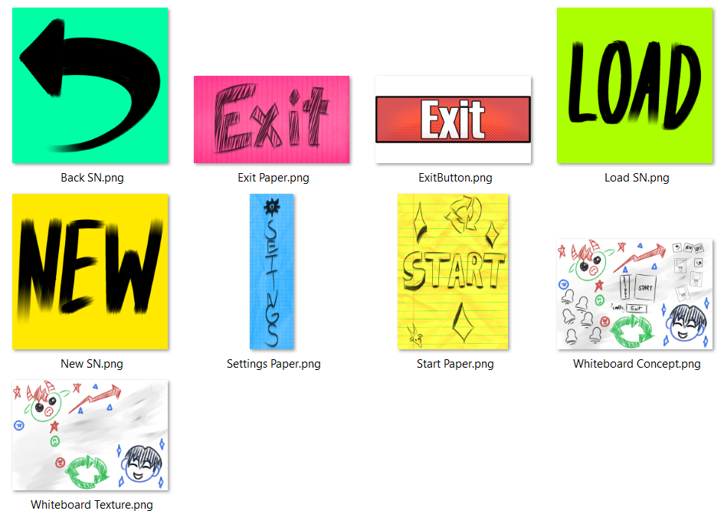 | 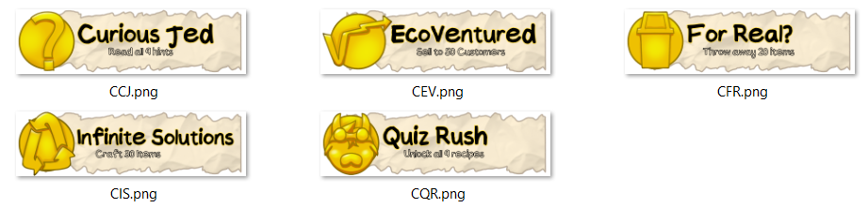
Main Menu Textures (Main menu Buttons and Whiteboard Texture) | Achievements (All Achievement Cards
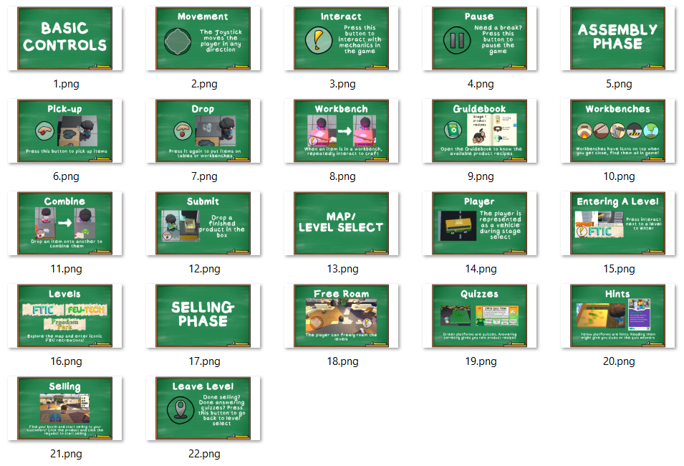
Written Tutorial (All pages of the written tutorial)

